NUC1XX Cortex M0 Series
FreeRTOS
Application Note

Table of Contents
1. Introduction 3
1.1 Introduction 3
2. User Method 4
2.1 Usage 4
3. Code Section 5
3.1 Demos usage 5
3.2 main function 7
3.3 Execution Result 10
4. Revision History 11

Introduction

1.1 Introduction
This document describes the Nuvoton port for FreeRTOS to the Cortex-M0 processor and how to use it.

The version of the FreeRTOS source code is v6.0.5, and this real time kernel is free, user can redistribute it and/or modify it under the terms of the GNU General Public License (version 2) as published by the Free Software Foundation AND MODIFIED BY the FreeRTOS exception. See the license.txt in directory \FreeRTOS\License\ for more details.

The FreeRTOS kernel include only three of four source files, task.c, list.c, queue.c are always required, and croutine.c also required if user want to use co-routine, in this port, we use task only, so croutine.c is not necessary.

FreeRTOS' kernel is customizable, in every project, a FreeRTOSConfig.h file is provided for user to custom kernel as user’ personal need.

Nuvoton provides two development environment port, Keil uVision4 and ARM IAR v5.41 for user to select.

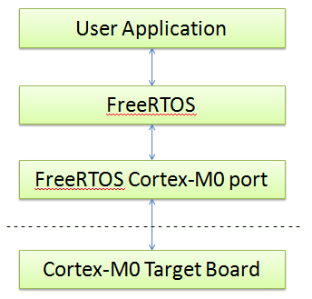
Figure 1-1. Code Block Diagram

User Method

Usage
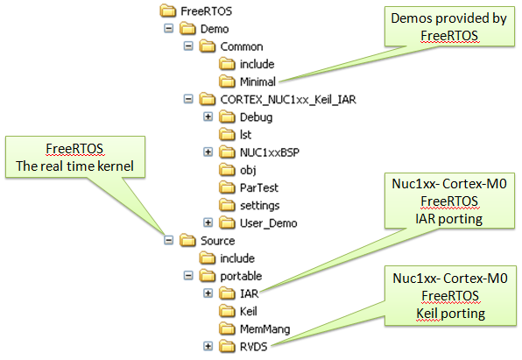
Figure 2-1. NUC1XX Cortex-M0 FreeRTOS Directory Structure

The source code for the FreeRTOS port for the Cortex-M0 with ARM Keil uVision4 and ARM IAR v5.41 are found in the following directory:

\FreeRTOS\Source\portable\

The Keil port consists of two files:
- portmacro.h contains processor and implementation specific #define constants, macros, and typedefs.
- port.c contains several simple C-language and inline assmbly functions, including the function that initializes the task stacks.

The IAR port consists of three files:
- portmacro.h contains processor and implementation specific #define constants, macros, and typedefs.
- portasm.s contains several simples assembly languages functions.
- port.c contains several simple C-language functions, including the function that initializes the task stacks.

3. Code Section

3.1 Demos usage
In this port, all demos except comtest.c provided by FreeRTOS are added to the Keil and IAR project and have been tested, user can decide which one is to test by configuring macro definitions in the App_Cfg.h.

Please pay attention that user can only set some of macro definitions 1 at a time because of limitation of target board RAM size.

Following are macro definitions of App_Cfg.h.

#define LED_TEST 0
#define BLOCK_Q_TEST 0
#define POLL_Q_TEST 0
#define SEM_TEST 0
#define MATH_TEST 0
#define BLOCK_TM_TEST 0
#define REMUTEX_TEST 0
#define COUNTSEM_TEST 0
#define GENQ_TEST 0
#define DYNAMIC_TEST 0
#define QPEEK_TEST 0
#define INTQ_TEST 0
#define ALT_BLOCKQ_TEST 0
#define ALT_BLOCK_TEST 0
#define ALT_POLLQ_TEST 0
#define ALT_QUEUE_TEST 0
#define MATH_F_TEST 0
#define SUICID_TEST 0
#define CHECK_TEST 0
#define UART_TEST 0
#define THREAD_TEST 1 // We use this test as a sample

In FreeRTOS, we create an application in an independent C source file, take thread test demo as an example, we create tasks and define them in a Thread_Test.c file, and provide a function interface to main function, so it will be very easy for user to add or remove an application from the project.

Following is the function interface and tasks definition of Thread_Test.c.

void vStartThreadTasks( void )
{
xTaskCreate( Thread_Task1, ( signed char * ) "Th_Task1", THREAD_TEST_STACK_SIZE, NULL, THREAD_TEST_PRIORITY, ( xTaskHandle * ) NULL );
xTaskCreate( Thread_Task2, ( signed char * ) "Th_Task2", THREAD_TEST_STACK_SIZE, NULL, THREAD_TEST_PRIORITY, ( xTaskHandle * ) NULL );
}

void Thread_Task1( void *pvParameters )
{
portTickType xLastTime1;

/* Get current system TickCount. */
xLastTime1 = xTaskGetTickCount();

for( ;; )
{
/* Run a time every 400 milliseconds. */
vTaskDelayUntil( &xLastTime1, 400 );
printf("Task1 called-\n");
}
}

void Thread_Task2( void *pvParameters )
{
portTickType xLastTime2;

/* Get current system TickCount. */
xLastTime2 = xTaskGetTickCount();

for( ;; )
{
/* Run a time every 800 milliseconds. */
vTaskDelayUntil( &xLastTime2, 800 );
printf("Task2 called--\n");
}
}

3.2 main function
The main function define is in the main.c.

int main( void )
{
#ifdef DEBUG
debug();
#endif

/* Configure realitive hardware platform. */
prvSetupHardware();

/* Start the standard demo tasks. */
#if LED_TEST
vStartLEDFlashTasks( mainFLASH_TASK_PRIORITY );
#endif
#if POLL_Q_TEST
vStartPolledQueueTasks( mainQUEUE_POLL_PRIORITY );
#endif
#if BLOCK_Q_TEST
vStartBlockingQueueTasks( mainBLOCK_Q_PRIORITY );
#endif
#if SEM_TEST
vStartSemaphoreTasks( mainSEM_TEST_PRIORITY );
#endif
#if MATH_TEST
vStartIntegerMathTasks( mainINTEGER_TASK_PRIORITY );
#endif
#if BLOCK_TM_TEST
vCreateBlockTimeTasks();
#endif
#if REMUTEX_TEST
vStartRecursiveMutexTasks();
#endif
#if COUNTSEM_TEST
vStartCountingSemaphoreTasks();
#endif

#if GENQ_TEST
vStartGenericQueueTasks( mainGENQ_TASK_PRIORITY );
#endif
#if DYNAMIC_TEST
vStartDynamicPriorityTasks();
#endif
#if QPEEK_TEST
vStartQueuePeekTasks();
#endif
#if ALT_QUEUE_TEST
vStartAltGenericQueueTasks( tskIDLE_PRIORITY );
#endif
#if ALT_BLOCKQ_TEST
vStartAltBlockingQueueTasks( tskIDLE_PRIORITY + 2 );
#endif
#if ALT_BLOCK_TEST
vCreateAltBlockTimeTasks();
#endif
#if ALT_POLLQ_TEST
vStartAltPolledQueueTasks( tskIDLE_PRIORITY + 2 );
#endif
#if MATH_F_TEST
vStartMathTasks( tskIDLE_PRIORITY );
#endif
#if INTQ_TEST
vStartInterruptQueueTasks();
#endif

/* Start demo tasks. */
#if UART_TEST
vStartUARTTasks( mainUART_TASK_PRIORITY );
#endif
#if THREAD_TEST
vStartThreadTasks();
#endif

/* Start the tasks defined within this file/specific to this demo. */
#if CHECK_TEST
xTaskCreate( vCheckTask, ( signed portCHAR * ) "Check", mainCHECK_TASK_STACK_SIZE, NULL, mainCHECK_TASK_PRIORITY, NULL );
#endif

/* The suicide tasks must be created last as they need to know how many
tasks were running prior to their creation in order to ascertain whether
or not the correct/expected number of tasks are running at any given time. */
#if SUICID_TEST
vCreateSuicidalTasks( mainCREATOR_TASK_PRIORITY );
#endif
/* Start the scheduler. */
vTaskStartScheduler();

/* Will only get here if there was not enough heap space to create the
idle task. */
return 0;
}

3.3 Execution Result
The Hyper-terminal would output the following message:
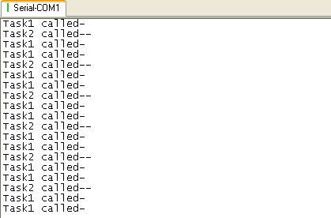

4. Revision History
Version | Date | Description
V1.00 | June 28, 2010 | - Created

